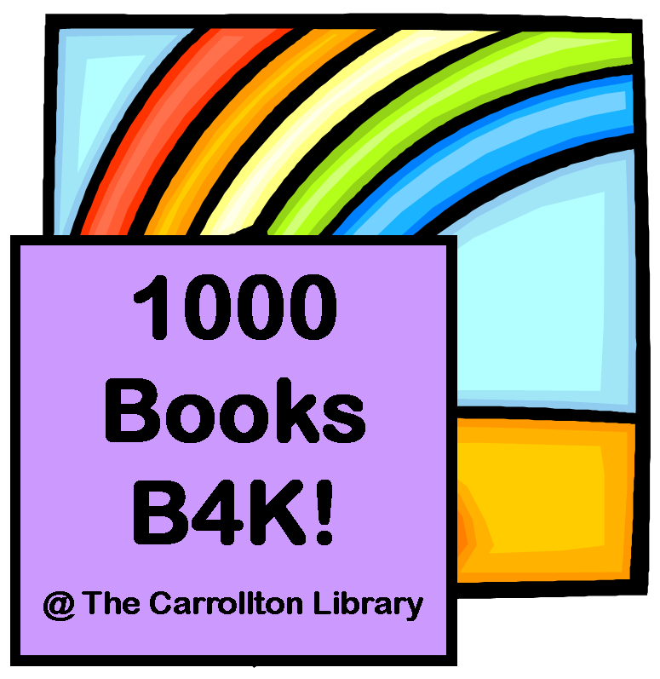
Get Ready to Read with
1000 Books Before Kindergarten!

1000 books may sound daunting but by reading only 3 books a day, your child can finish the program in just one year. By reading one book at bedtime every night, your child can finish the program in 3 years.

In order for children to build their vocabularies and become ready to read they must be exposed to words and their meanings at an early age. Research shows that children who have larger vocabularies become better readers. The more we read with them and talk with them, the larger their vocabularies become.

“Vocabulary size in optimal settings may increase exponentially in the early years (some estimate about seven words a day) (Snow et al., 1998), with children learning to comprehend words spoken to them before they are able to produce them on their own.” – Every Child Ready to Read Literature Review, 2010

The 1000 Books Before Kindergarten program is designed to make sure that your child is ready to read once they get to Kindergarten. Equipped with information about early literacy, you can easily help your child develop pre-reading skills throughout the day.

Point out signs and labels when you see them to increase your child’s print awareness. Allowing your child to see you reading will encourage print motivation. Pointing out and saying the names of letters when you see them will increase letter knowledge.

Within these helpful resources, you will find tips to boost your child’s reading readiness for kindergarten. You are your child’s first teacher and the library is here to help provide you with the early literacy resources you need.

To get started, stop by any branch of Blackwater Regional Library to register and pick up your reading log. For every 100 books read, your child will receive a certificate and a free book to add to their home collection!

